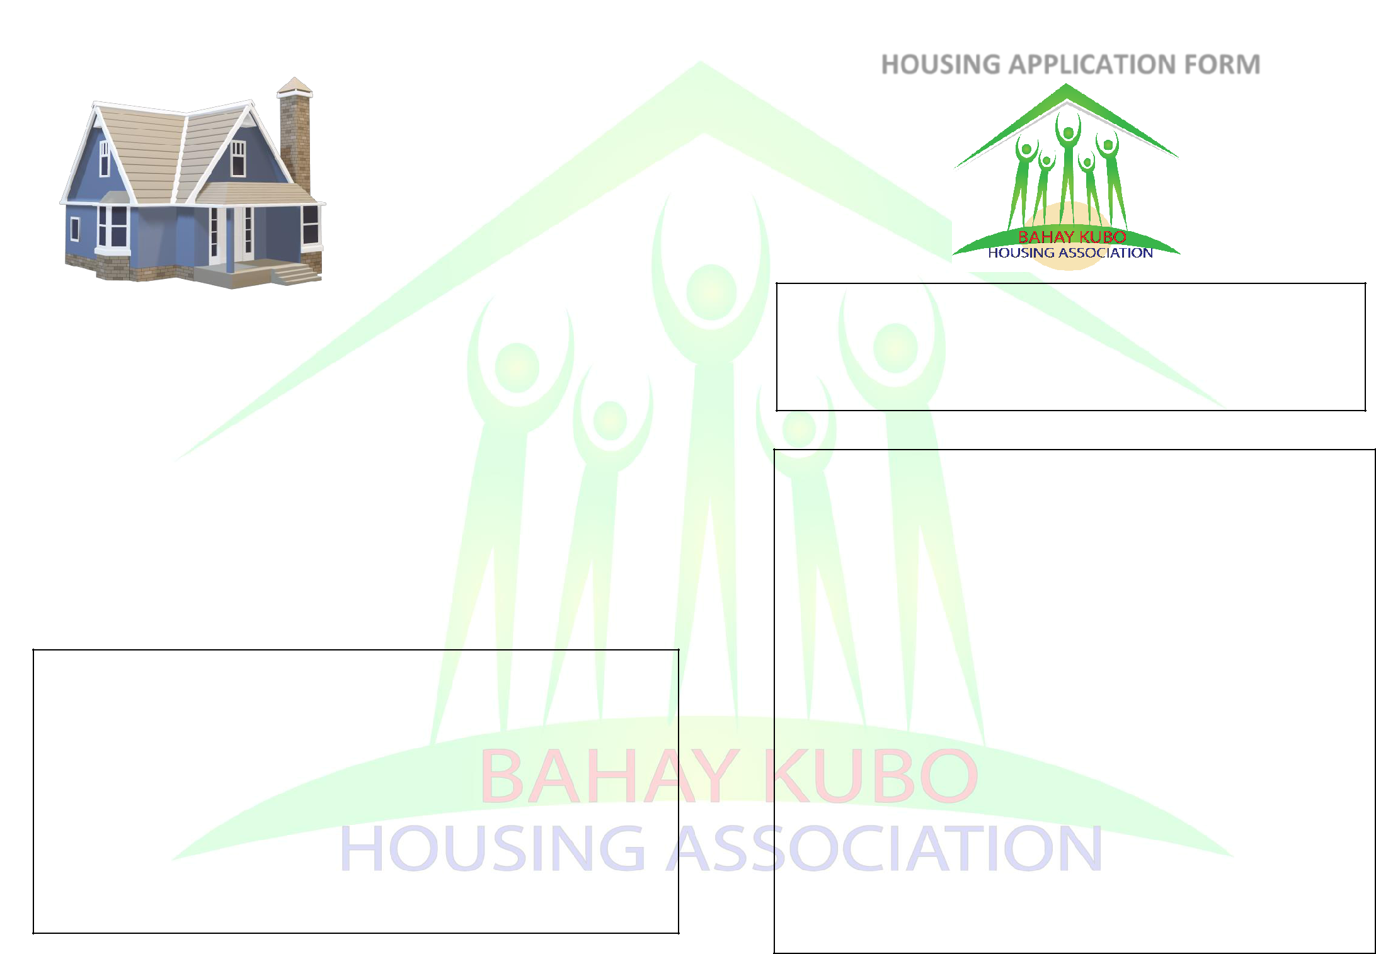
PLEASE RETURN THIS FORM TO:

Bahay Kubo Housing Association

Hackney CVS

The Adiaha Antigha Centre

24-30 Dalston Lane, London E8 3AZ T: 0208 801 1117
E: info@bahaykubo.org.uk

W: www.bahaykubo.org.uk

Bahay Kubo Housing Association was established in 1989. Our objective is to help Filipinos in Greater London gain access to quality affordable housing to help them lead fuller and more independent lives.

These are among the services we provide:

- Quality affordable housing for migrant communities.

- Professional services to ensure tenants’ needs are met.

- Effective and efficient repairs and maintenance.

- Activities and events for Filipino community in the UK.

For office use only:

Date received: ___________________________________

Referral Agency: ___________________________________

Reference No.: ____________________________________

Housing Officer: _____________________________________

Comments: __________________________________________________

_____________________________________________________________

HOUSING APPLICATION FORM

Please complete this form as fully as possible. It is designed to obtain information about you, your family and your present living conditions. If you want help filling in this form, please contact the office. Any information you give will be treated in strictest confidence. Please note that completing this form does not guarantee that you will be offered accommodation.

PERSONAL DETAILS:

Title: Mr/Mrs/Ms: _____________________

____________________________ ___________________________

Surname Given Name

Present address: ___________________________________________

_________________________________________________________

Post Code: ______________ Tel. No.: _______________________

Mobile No.: ___________________ Work No.: __________________

Applicant signature: ________________________________________

CURRENT HOUSING SITUATION:

1 . Are you in danger of losing your current home? YES NO

If yes, please give details: _________________________________

______________________________________________________

______________________________________________________

______________________________________________________

- Is your house unsatisfactory in any way? YES NO

If yes, please give details: _________________________________

______________________________________________________

______________________________________________________

3 . Do you suffer from any medical, social or other problem that makes

it difficult for you to find accommodation? YES NO

If yes, please give details: _________________________________

______________________________________________________

______________________________________________________

______________________________________________________

4 . In which borough are you currently located?

Camden Kensington & Chelsea Islington

Haringey Ealing Westminster

Hammersmith & Fulham Newham

Others (please specify): __________________________________

5 . Have you applied for Council Housing? Yes No

Date of application: _____________ Waiting list no. ____________

6 . Please provide the details of your previous addresses in the past five

(5) years:
ADDRESS | Date moved in | Date moved out
______________________ | ______________ | ____________
______________________ | ______________ | ____________
______________________ | ______________ | ____________
______________________ | ______________ | ____________
______________________ | ______________ | ____________
______________________ | ______________ | ____________

ETHNICITY:

What is your ethnic group?

A. White

a. British b. Irish c. Other: _______________

- Mixed/Multiple ethnic group

  - White and Black Caribbean

  - White and Black African

c. White and Asian d. Other mixed: ______________

C. Asian/Asian British

a. Indian b. Pakistani c. Bangladeshi d. Chinese

Other Asian/Asian British: ____________________________

D. Black/African/Caribbean British

a. African b. Caribbean c. Other: ___________________

E. Other Ethnic Group

a. Arab c. Other: _______________________________

EQUAL OPPORTUNITY:

We are committed to equal opportunities in employment and service delivery. The policies and practices of the Bahay Kubo Housing Association (BKHA) aim to promote an environment that is free from all forms discrimination and values the diversity of all people. We seek to treat people fairly and with dignity and respect.

We will take every possible step to ensure that no person working with BKHA, seeking employment with us, or any member of the public using our services will receive less favourable treatment on the grounds of their: Age, Disability, Gender Reassignment, Marriage and civil partnership, Pregnancy and maternity, Race, Religion or belief, Sex and Sexual Orientation.

INCOME:

1. | Are you currently working at the moment? YesNo
2. | If you are currently working, is your job
 | Full time | Part-time | Seasonal

3. What is your nature of work?

Domestic worker |  | Nursing and Auxillary |  | Catering
Manufacturing |  | Civil Service |  | Arts/Theatre
Professional/Managerial |  |  | Retail/Services
Building/Construction |  |  | Administrative /Clerical
4. | Do you access state benefits? |  | Yes | No
5. | Which of the following benefits do you receive?
Income Support |  | Family Credit |  | Child benefit
Housing Benefit |  | Universal Credit |  | Others ____________
6. | In which band is your net weekly income?
 | Less than £100 |  | Between £101 and £150
 | Between £151 and £200 |  | Between £201 and £250
 | Between £251 and £300 |  | More than £300
7. | Is there another wage-earner in your household? YesNo
8. | How much additional income does s/he bring in weekly?
 | No other wage-earner |  | Less than £100
 | Between £101 and £150 |  | Between £151 and £200
 | Between £201 and £250 |  | More than £250

- Please use this space to give any additional information that may help your application.

____________________________________________________

____________________________________________________

____________________________________________________

____________________________________________________

DISABILITY:

Do you consider yourself to have disability? Yes No

If yes, please describe: ____________________________________________

_______________________________________________________________

Does anybody in the household have disabilities? Yes No

If yes, please describe: ____________________________________________

_______________________________________________________________

Do you or in the household require mental or emotional support? Yes No If yes, please describe: ____________________________________________

_______________________________________________________________

Do you or anyone in the household receive financial support for care,

medicines or food? Yes No

If yes, please describe: ____________________________________________

_______________________________________________________________

Bahay Kubo Housing Association have a GDPR policy that details our commitment to stakeholders, contractors and staff confidentiality and data storage, and we are committed to its five main areas:

- That we will process all personal data fairly and lawfully;

- That we will only process personal data for specified and lawful purposes;

- That we will endeavour to hold relevant and accurate personal data, and where practical, we will keep it up to date;

- That we will not keep personal data for longer than is necessary;

- That we will keep all personal data secure.

PRESENT ACCOMMODATION SITUATION:

1. Which of the following describes your present situation:

Council Tenant Home-owner

Housing Association tenant Tenant of Private landlord

Worker living with employer Others: __________________

2. What type of accommodation do you live in?

House Flat Self-contained bedsit

Room of yourself in a shared house

Room shared with another person Others: ________________

3. Which of the following describe your tenure of accommodation?

Permanent accommodation Living with employer

Assured short-life accommodation Living with friends/relatives

Unassured temporary accommodation Others: _____________

- Do you share facilities with other tenants? Yes No

- If yes, which facilities do you share with other tenants?

Kitchen | Sitting room | Toilet | Garden | Others: _____________
6. With how many people do you share these facilities?
One | TwoThree | Four Five |  | More than five
7. How often do you pay your rent?
Weekly Every two weeks |  |  | Monthly
Quarterly | Yearly |  | Others: ___________________
8. In which band is your weekly rent?
I do not pay rent |  | less than £50Between £50 and £75
Between £75 and £100 |  |  | Between £101 and £150
Between £151 and £200 |  |  | More than £200

9. How much space do you require for a house?

One bedroom Two bedrooms Three bedrooms

Four bedrooms Five bedrooms Others: _______

- If you have any other requirements that should be taken into account if an offer of accommodation is made, please explain below:

___________________________________________________

___________________________________________________

___________________________________________________

___________________________________________________

HOUSEHOLD DETAILS:

Please give details of all those whom you are applying to be housed:

NAME | DATE OF BIRTH |  | SEX | RELATIONSHIP TO
 |  |  |  | APPLICANT
______________________ |  | __________ | ___ | ____________________
______________________ |  | __________ | ___ | ____________________
______________________ |  | __________ | ___ | ____________________
______________________ |  | __________ | ___ | ____________________

PREFERENCES:

In which areas of London do you prefer to live?

Camden | Kensington and Chelsea |  | Islington
Haringey | Ealing | Westminster | Newham
Hammersmith and Fulham |  | Others: __________________
1. How did you hear about Bahay Kubo Housing Association?
Website | Friend | Facebook | Others: _____________

Referral from: _______________________________________________

